How to configure ISUP in Yate
We will set up an ISUP configuration in Yate to make calls.
Below is an image that describes the configuration.
So there are 2 Yate that are configured as a softswitch, each of them will act as a SIP server and a SS7 SEP in the network. The Clients used will be Yate SIP Clients that will communicate with Yate on SIP protocol, then the call is routed through SS7 to the corresponding SEP. The message will be read at each level in the order shown in the image: SCTP, M2PA, MTP3, ISUP and then routed in SIP and sent to the destination.

This is based on the modified yate from my repo:
https://github.com/svinson1121/yate/tree/main
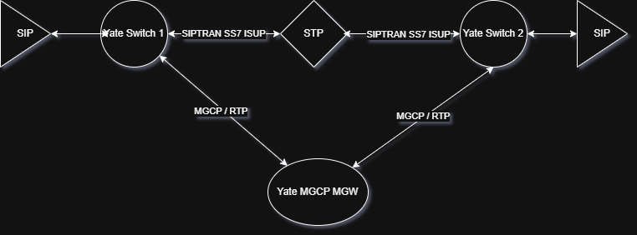
** The STP in the above image is optional.

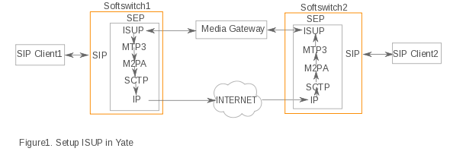
ISUP configuration Prerequisite
- SCTP:
On the machines where ISUP will be configured SCTP must be installed and compiled.
- Yate:
Download a copy of Yate
Yate needs to be configured with command: ./configure --enable-sctp=yes.
Parameters & Source
Parameters:
- pointcodetype
- format
- remotepointcode
- lockgroup
- earlyacm
- inn
- numplan
- numtype
- presentation
- screening
- callercategory
- channelsync
- userparttest
- t9
- continuity
- confirm_ccr
- drop_unknown
- ignore-grs-single
- ignore-cgb-single
- ignore-cgu-single
- duplicate-cgb
- parttestmsg
- ignore-unknown-digits
- sls
- maxcalleddigits
- print-messages
- extended-debug
Source:
- libs/ysig/isup.cpp
Building the setup
We are going to use 2 Softswitches with Yate installed and configured with ISUP to make calls (see the configuration for Server1 and Server2).
Each ISUP will have the same list of circuits.
The transport will be done over SCTP and is set in sigtransport.conf file.
The configuration of SS7 signaling will be done in ysigchan.conf and will consist of: Linkset: MTP3, Link: m2pa and Trunk: ISUP.
The voice is configured in mgcpca.conf.
For transmitting the voice another machine will be used (see Server3) that will act as a Media Gateway.
Server1 (IP:192.168.168.156)
Transport it is done over SCTP:
sigtransport.conf
;The name of the section identifies the connection
[sctp-m2pa]
type=sctp
stream=false
;Primary local address
local=192.168.168.156:5050
remote=192.168.168.200:6999
SS7 signalling configuration
ysigchan.conf
;SS7 MTP3 network (linkset)
[mtp3]
type=ss7-mtp3
;Comma separated list of point code types used to map an
;incoming network indicator to a specific point code type
netind2pctype=ITU
netindicator=national
;Declare a local pointcode for the SS7 network
local=ITU,0-0-6
;Build an adjacent route for the SS7 network
adjacent=ITU,0-0-5
;Name of a SS7 Layer 2 link to create in the linkset
link=m2pa

;SS7 M2PA link
[m2pa]
type=ss7-m2pa
sig=sctp-m2pa

;SS7 ISUP trunk
[isup]
type=ss7-isup
netindicator=national
pointcodetype=ITU
pointcode=0-0-6
remotepointcode=5
defaultpointcode=6
voice=mgcpca
Voice it is set in:
mgcpca.conf
[gw mgcpca]
user=ACgw100
media_token=yes
host=192.168.168.77
port=2427
address=192.168.168.77
voicechans=1-15.17-31
chans=31
start=1

[engine]
Configure user for test:
regfile.conf
[333]
password=mysecret1
Server2 (IP:192.168.168.200)
Transport it is done over SCTP:
sigtransport.conf
[sctp-m2pa]
type=sctp
stream=false
local=192.168.168.200:6999
remote=192.168.168.156:5050
SS7 signalling configuration:
ysigchan.conf
[mtp3]
type=ss7-mtp3
netind2pctype=ITU
netindicator=national
local=ITU,0-0-5
adjacent=ITU,0-0-6
link=m2pa

[m2pa]
type=ss7-m2pa
sig=sctp-m2pa

[isup]
type=ss7-isup
netindicator=national
pointcodetype=ITU
pointcode=0-0-5
remotepointcode=6
defaultpointcode=5
voice=mgcpca
Voice it is set in:
mgcpca.conf
[gw mgcpca]
user=Acgw200
media_token=yes
host=192.168.168.77
port=2427
address=192.168.168.77
voicechans=1-15.17-31
chans=31
start=1

[engine]
Configure user for test:
regfile.conf
[222]
password=mysecret2
regexroute.conf
[default]
.*=sig/\0;trunk=isup
Server3 (IP:192.168.168.77)
Configuring mgcp gateway and the 2 EndPoints that are set in each machine (in Server1 and in Server2):
mgcpgw.conf
[engine]
enabled=yes
address=0.0.0.0
request_ack=no
send_provisional=no
retrans_interval=0
retrans_count=0

[ep ACgw100]
local_user=ACgw100
local_host=192.168.168.77
remote_host=192.168.168.200

[ep ACgw101]
local_user=Acgw200
local_host=192.168.168.77
remote_host=192.168.168.156
Testing the setup
Server1 and Server2 started then Server3.
Two Yate clients can be used to register the users configured. Then calls are made from one client to another.

